Setting Up C++ in Visual Studio

To begin programming in visual studio, you will need to first download the program. Go to <https://www.visualstudio.com/downloads/> and download the version you would like. If you are unfamiliar with the different versions of Visual Studio download Professional. Professional is the most commonly used. After the download is complete, you are going to need to add extensions. A popular language is C++, to add it open Command Prompt with administrator rights on your pc. Once it opens up execute this line of instructions, **vs_community.exe --layout c:\vs2017layout --add Microsoft.VisualStudio.Workload.NativeDesktop --includeRecommended --lang en-US.**

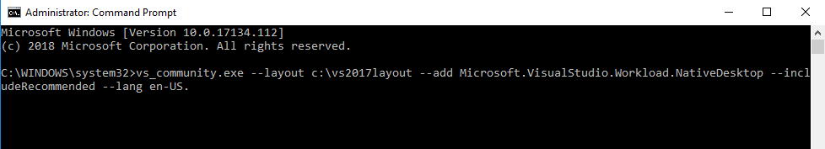

Now your computer will have the ability to program with C++. Navigate to the Visual Studio launcher in your start menu on Windows 10. The program will ask you to login with a Microsoft account. If you must create one, provide the same email address you used when downloading the program initially to avoid confusion.

It is time to create your first program. Move your cursor to the top left corner and find the file tab, you need to create a new project. Hit File, new, then project. Your screen should now look like the following photo.

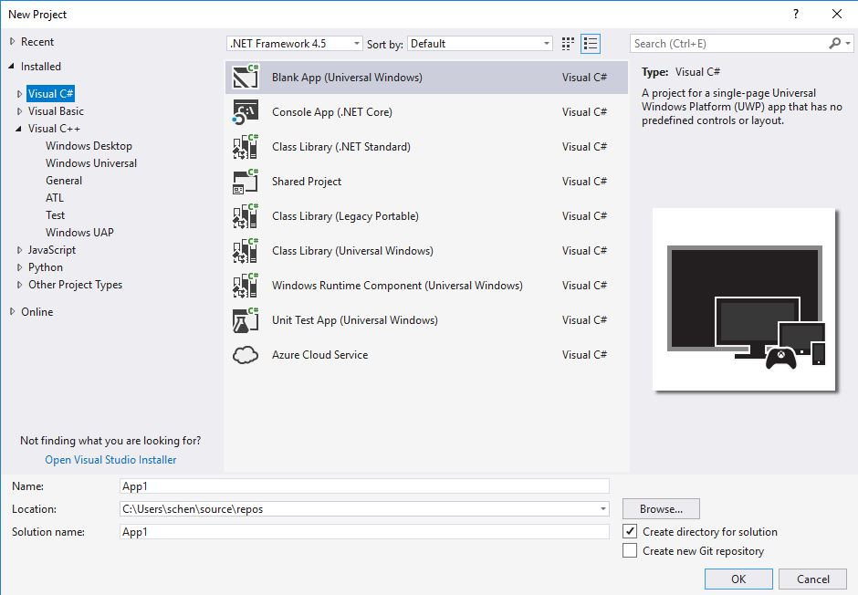

This window is where the programing language is chosen for the new project. For C++, find the Visual C++ tab and expand it to show all categories. Now, in the project options under C++ select Empty Project. At the bottom of the window, give the project a name and a location to save to. It’s not recommended to use the default save location. It is difficult to find. To make things easy, create a folder on your desktop and call it “**Visual Studio Projects**”. Inside this folder, create another folder called “**C++**” like shown below. This will help you organize projects. Click OK, now you have created your first C++ project.

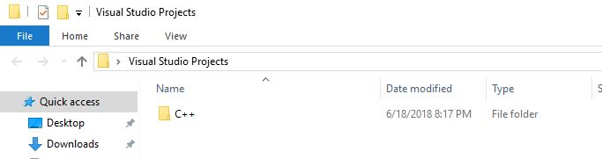 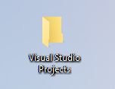

You are going to be greeted with a blank screen. You need to had source files and/or header files. Depending on your project right click one or the other, select add then new item. If you are unsure if you need a header file or source file, right click on source file (it is used more often). A window will pop up that looks like the following. For a source file select the .cpp option and for header select the .h option. Give your file a name and select add. Now it is a part of your project.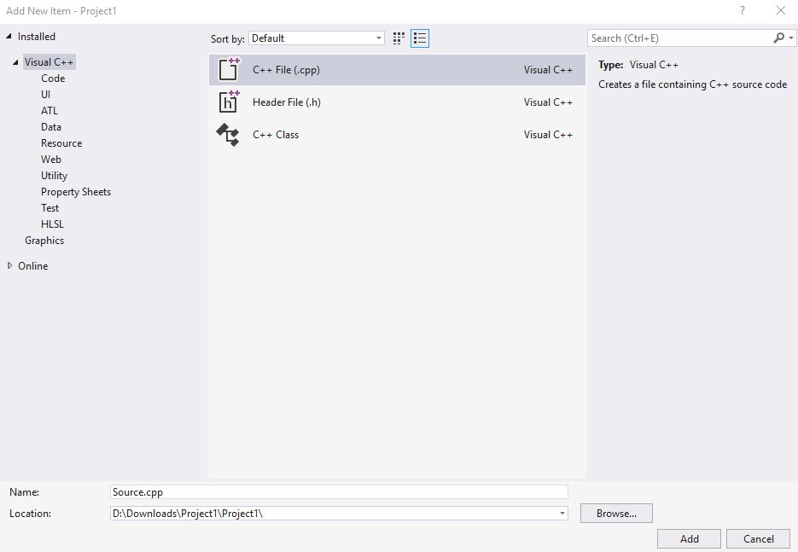

You should see a line pop up on the screen. This is the first line of code. You can now successfully create C++ programs and projects!